# User Interface Wireframes

### Login screen:

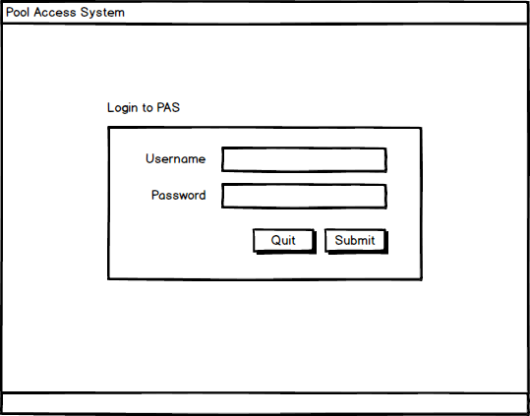

The Login Screen is used to verify users with username and password credentials. Successful verification will open the main program, defaulting to the Find Swimmer screen. Unsuccessful authentication will display an error message at the bottom of the screen

Instructions:

* Type username and password into the respective fields
* Click submit to authenticate username and password

### Find Swimmer screen:

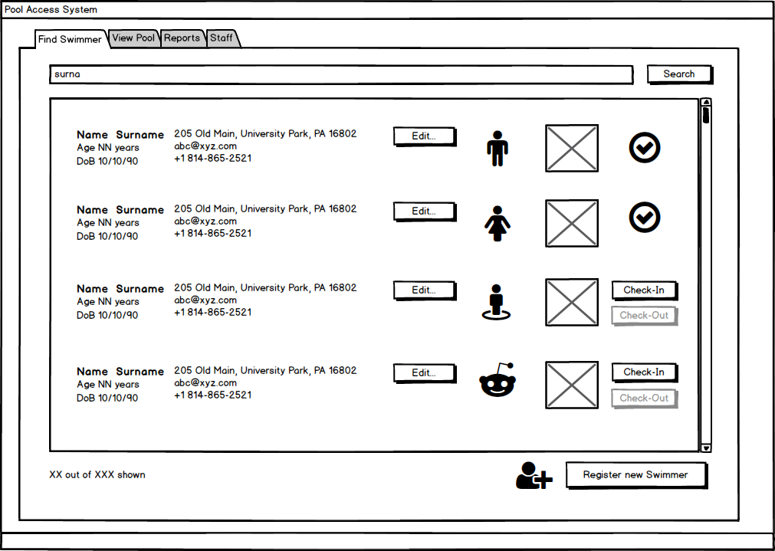

The Find Swimmer screen displays a list of all swimmers currently registered to the system along with their general information and picture. The user can refine the list by searching for the swimmer’s name or key words in the swimmer’s general information. If the user is a manger, they can edit the swimmer’s profile or register a new swimmer. The user can also check-in and check-out swimmers.

Instructions:

* Search by Name or Key Word
  + Type a name or key word as it would appear on the screen (i.e. phone numbers must be entered as XXX-XXX-XXXX) into the search field and click the search button. The screen will display matching results or an error message.
* Edit Profile
  + Click the ‘Edit’ button with in the row of the swimmer to be edited
* Check-In/Check-Out Swimmer
  + Click the check-in or check-out button within the row of the swimmer to be checked into or out of the pool. The buttons will alternate in active status to reflect whether a swimmer is in or out of the pool.
* View Full Profile
  + Click the name of the swimmer
* Navigate to another use case
  + Click on the tab on the top of the screen that corresponds to the desired use case

### View Pool screen:

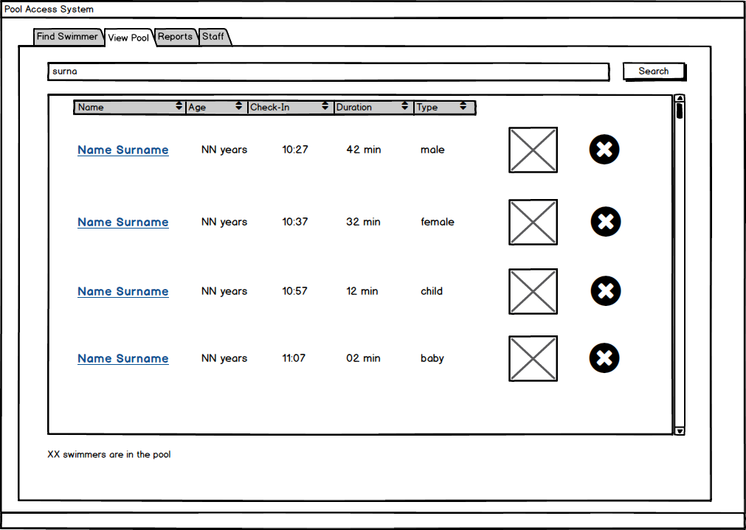

The View Pool Screen displays a list of swimmers currently checked in and active at the pool along with the swimmers’ age, check-in time, duration spent at the pool, type (male, female, child, baby), and picture. The list can be further refined by name or sorted. The user may access a swimmer’s full profile information or check swimmers out of the pool.

Instructions:

* Search by Name
  + Type a first or last name into the search field and click the search button. The screen will display matching results or an error message.
* Toggle order by Name, Age, Check-In Time, Duration at the Pool, or Type
  + Click the respective category in the title bar to sort the list accordingly, an additional click will reverse the order
* Check-out Swimmer
  + Click the ‘X’ on the row of the swimmer to be checked-out. The swimmer will be removed from the list.
* View a Swimmer Profile
  + Click the underlined name of the swimmer.
* Navigate to another use case
  + Click on the tab on the top of the screen that corresponds to the desired use case

Reports/View Visits screen:

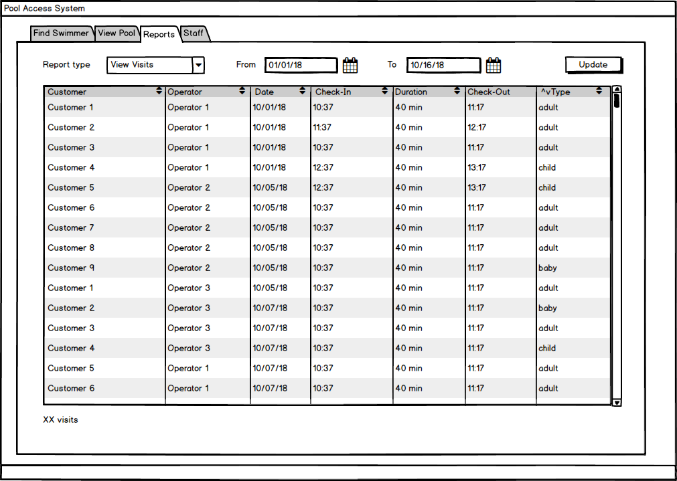

### Reports/View Customers screen:

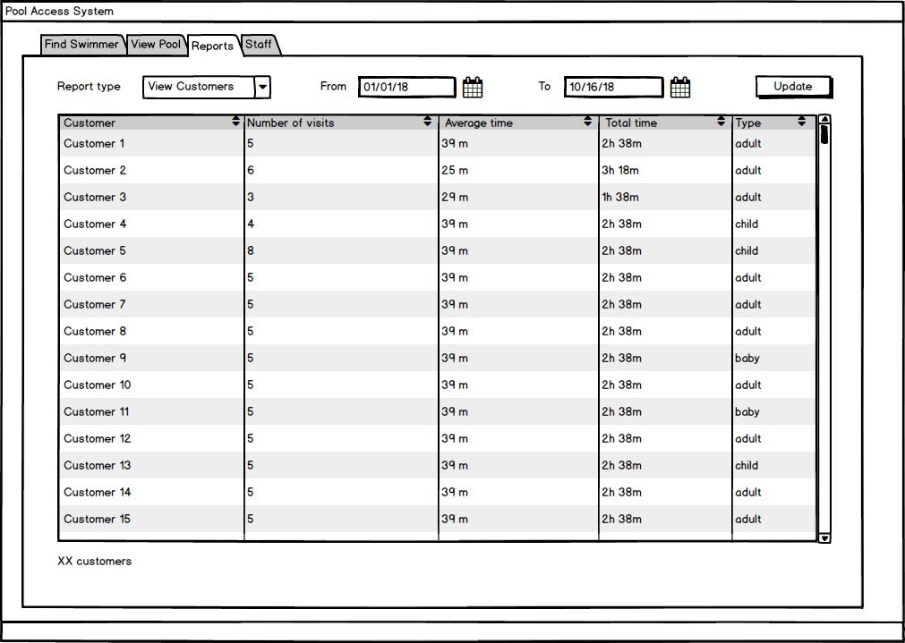

### Reports/Attendance screen:

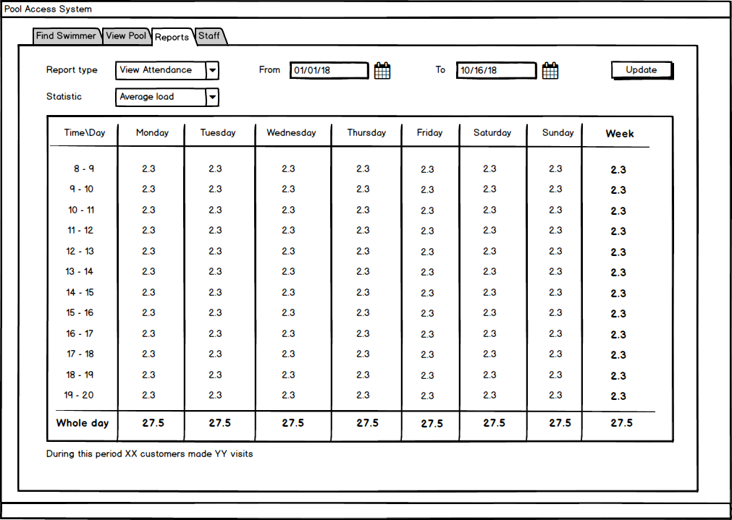

### Staff screen:

